# UNDERSTANDING WEB SERVICE CREDENTIALS

## OVERVIEW

This document explains the purpose of Web Service Credentials and explains how to retrieve Web Service Credentials from DSElk.

## WHAT ARE WEB SERVICE CREDENTIALS?

When a Facility utilises web service integration each web service request that they make (whether submitting new client data or retrieving client or payment data) must be made using a pair of web service credentials. The Data Transfer Web Service Document, and specifications, refer to this pair of credentials as the CustomerID and CustomerCode.

When a Facility makes a web service request using a CustomerID and CustomerCode the CustomerID tells us which Facility the request should be associated with and the CustomerCode identifies the associated Facility Account.

## GUIDELINES FOR SHARING WEB SERVICE CREDENTIALS

It is important to recognise that web service credentials effectively act as a username and password when making web service requests. You should treat them with the same degree of care and diligence that you would apply to website user names and passwords. If web service credentials for a Facility fall into the wrong hands they could potentially be used to retrieve client information, i.e. A malicious user could extract complete client records including address, contact and payment information (with the exception of sensitive credit card data which cannot be retrieved using web service requests).

Web service credentials should only be shared with authorised parties.

Web service credentials should only be shared with users when it is known that they have been through a testing process involving the Debitsuccess IT Team.

## HOW TO EXTRACT WEB SERVICE CREDENTIALS FROM DSELK

The Customer ID for a Facility can be retrieved by looking at the Facility - Data Transfer Tab in DSElk. It is labelled as “Clubware Synch ID”.

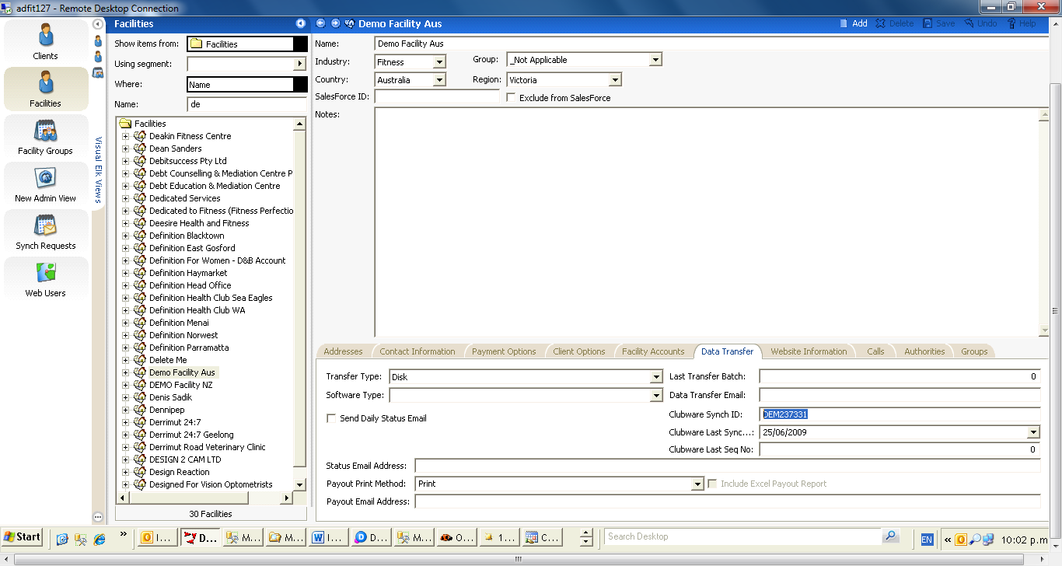

The Customer Code for a Facility Account can be accessed from the Facility Account Grid View.

Identify the appropriate Facility in DSElk and expand it in the Tree View to see the underlying Folders. Select the Facility Accounts folder.

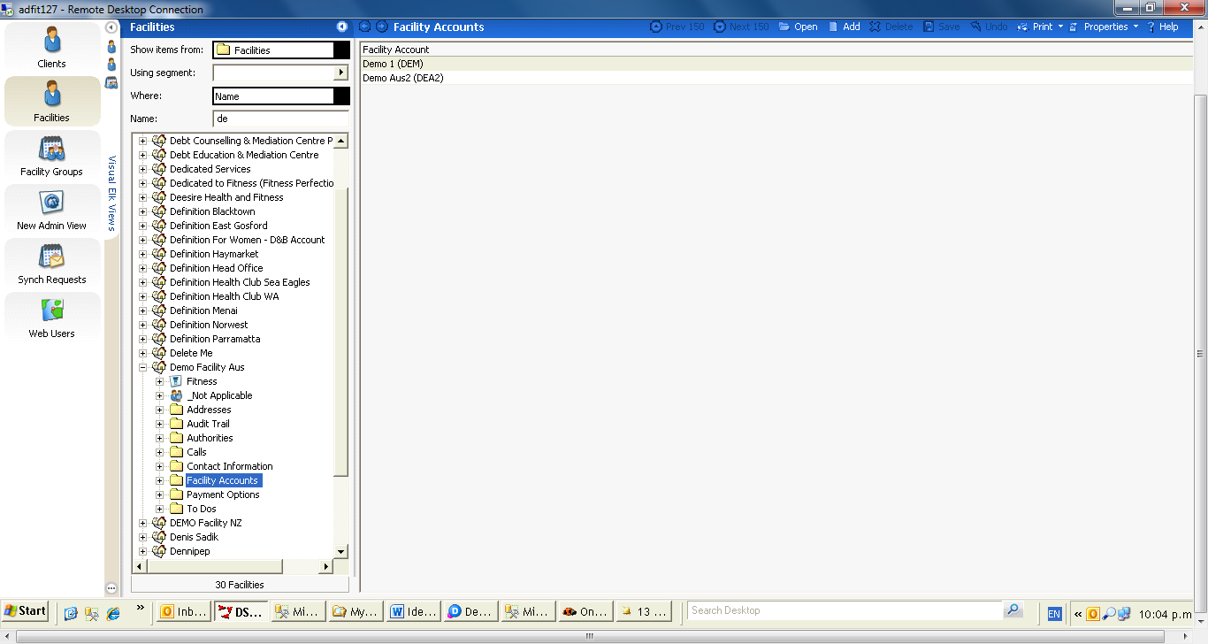

The Customer Code for a Facility Account is stored in a Field labelled “CampaignID”. If you cannot see this in your grid view, click Properties in the Grid Menu Bar, and then select Fields.

Click and drag CampaignID from the Fields box to the Grid Column Header (You may then need to click to another view and back to the Facility Account grid to refresh the Grid view). The Campaign ID (Customer Code) for each Facility Account is visible in the Facility Account Grid.

